Comparative HW 4: Comparing Women’s Movements

A resource, as pertains to political mobilization and collective action, may be defined as “a new or reserve source of supply of support; a fresh or additional stock or store available at need; something in reserve or ready if needed” (Edwards, McCarthy, 116). While the resources that enable the social movement organizations (SMOs) that drive social change to function are logically understood to include human time and effort, a clearer understanding of the individual relevance of resources requires greater specificity. The resources that support SMOs can be classified under a “five-fold typology of moral, cultural, social-organizational, human, and material,” (Edwards, McCarthy, 117), overarching classifications that incorporate not only discretionary resources, but also more intangible resources, such as the tacit skill sets activists bring to their movements, or the external moral support celebrities may extend. However, the key resource of any SMO is arguably its organizational structure. As the “mobilization of money and labor depends on the creation and establishment of movement structures,” (McCarthy, Zald, 1224), any efficacy resource that backs a SMO is determined by the strength of its organization.

Women’s groups, as with most SMOs, have a variety of resources gained through several different methods of appropriation across the five types (see Fig 1). Just as important, however, is the relationship such a group has with the media, government, or other parties and SMOs, especially when contrasting movements in different states. The regime type of a state and the level of liberalization is a key factor in determining the resources available to the movement, and freedom by which the movement can operate.

Figure 1
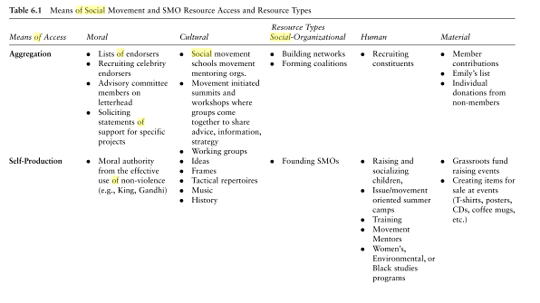
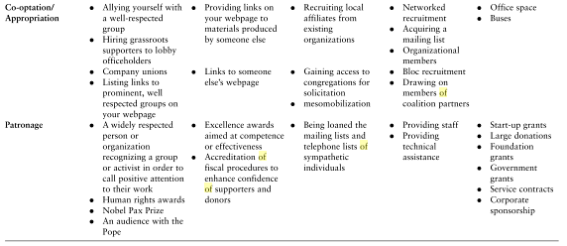
Source: Means of Social Movement, “Resources and Social Movement Mobilization”, The Blackwell Companion to Social Movements, Apr 2014, Web, Table 6.1.

In each of the six focus countries –the United States, Germany, India, Myanmar, Russia, and China – a range of resources supports women’s groups. The freedoms the state allows or the restrictions the state imposes upon SMOs are crucial to each individual movement.

Both the United States and Germany, as liberal democracies, constitutionally protect liberties such as freedom of expression and peaceful assembly, allowing for the secure development of SMOs. Both have Freedom House scores of 1.0, indicating the highest level of freedom, which is calculated by combining a score for both civil liberties and political rights. Women’s movements in both states have access to a free media and uncensored internet. Women’s rights are well protected by law, and are effectively enforced by the judiciary.

India has a Freedom House score of 2.5, but is yet a democracy operating on mostly liberal values. There are some restrictions on assembly, and foreign funding to non-government organizations can be denied. India’s media has more constrained than those of the United States or Germany, but the internet is mostly unrestricted. The criminal justice system is flawed, failing to “provide equal protection to marginalized groups,” (Freedom House) including women.

Of the semi-authoritarian regimes, both Russia and Myanmar have Freedom House scores of 5.5, and are deemed “not free”. Russia has “consistently reduced the space for freedom of assembly and association” (Freedom House) and both states require organizations to gain some form of permission before planning a demonstration. In Myanmar this is explicit in the legislation of the Peaceful Assembly and Peaceful Procession Law, whereas in Russia, “vague laws on extremism grant the authorities great discretion to crack down on any speech, organization, or activity that lacks official support,” (Freedom House). Both states have restricted media and internet censorship. In Russia, “women have particular difficulty achieving political power,” (Freedom House) whereas in Myanmar, although women are underrepresented in civil service, laws have traditionally existed for the protection of women.

The resources available to SMOs are most limited in the last focus country, China. The People’s Republic of China (PRC) is the least free of the six, with a Freedom House score of 6.5, close to the lowest possible score of 7. In China, SMOs or indeed any kind of protest movement are under the strictest of regulations. The Chinese Communist Party enforces its single-party dominance of the government without toleration of “any kind of organized or independent political parties” (Freedom House). The Chinese control of the media and internet is incredibly restrictive. For example, the Central Propaganda Department of the PRC regularly issues directives to the media instructing what can and cannot be mentioned or emphasized in media releases (China Digital Times). SMOs require governmental permission to organize or risk criminal punishment (Perry, 14).

McAdam defines political opportunity structure as “any event or broad social process that serves to undermine the calculations and assumptions an which the political establishment is structured” (Heuer). A structure that reflects opportunity for an SMO is characterized by increased regime openness, elite fragmentation, and the presence of influential allies, potentially foreign entities, or a reduction in the repressive capacity of the state. Of the six focus countries, the United States and Germany are the most open to the mobilization of women’s movements, followed by India, Myanmar, Russia, and China respectively. Interestingly, however, the Social Progress Imperative Index, ranks the countries in a startlingly different order for the opportunity component of “women treated with respect”. The Index ranks the states as, from highest to lowest, China, Germany, the United States, India, and Russia (Myanmar is not available in the results) (see Fig. 2). Despite this specific regard to the attitude towards women, the general ability of SMOs to influence politics in each state remains largely determined by its regime type.

Figure 2
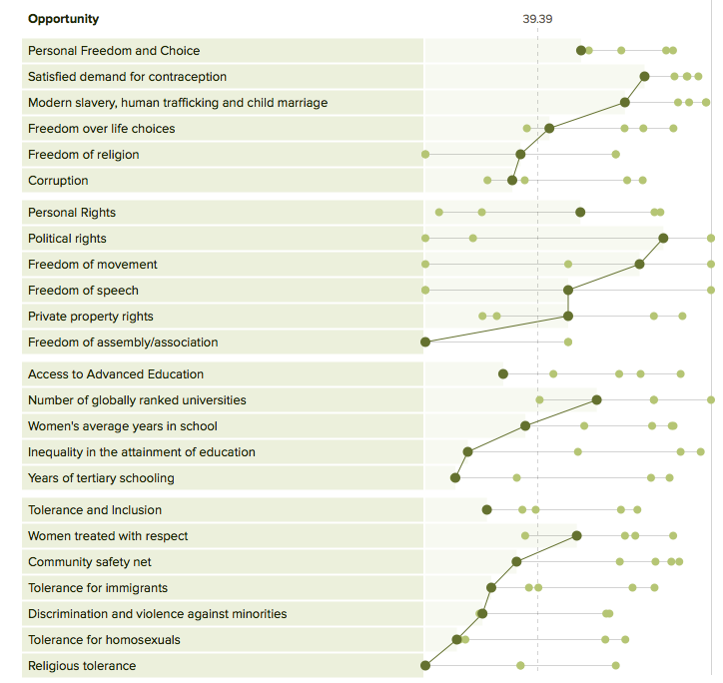
Source: India, China, Russia, United States, Germany comparison chart, Opportunity Dimension. Social Progress Index. Apr 2014, Web, Performance Chart.

Following this logic, women’s movements are most likely to face repression under the authoritarian regimes in Russia, China, and Myanmar. Women’s movements in India are less likely to face repression, but are will have to work harder to mobilize and influence politics than movements in the United States and Germany.

Women’s movements are more likely to succeed in the more liberalized states than in the authoritarian states. Women’s SMOs are most likely to succeed in Germany and the United States, have less of likelihood of success in India and Myanmar, and are least likely to succeed in China and Russia.

Women’s groups will be more successful in achieving their goals in liberal states where 1) basic liberties, such as freedom of assembly and expression, are respected and 2) where the government is responsive to collective action performed by SMOs. Movements that have adapted to professionalism and have shaped themselves into institutional social movements are more likely to succeed (Kohli, 243). The Social Progress Imperative Index reflects the key focus on liberal values and liberties (see Fig. 3), and the benefit of government responsiveness, especially for women’s movements, is shown in Social Movements and Targets (see Fig. 4):

Figure 2
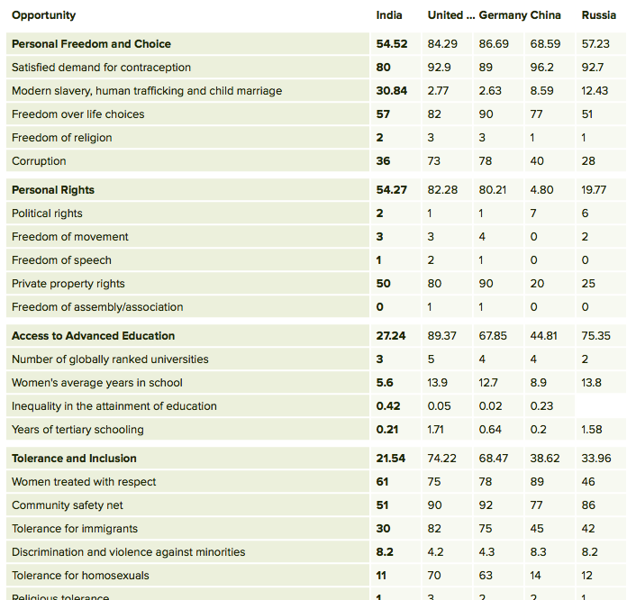
Source: India, China, Russia, United States, Germany comparison chart, Opportunity Dimension. Social Progress Index. Apr 2014, Web, Data Table.

Figure 3
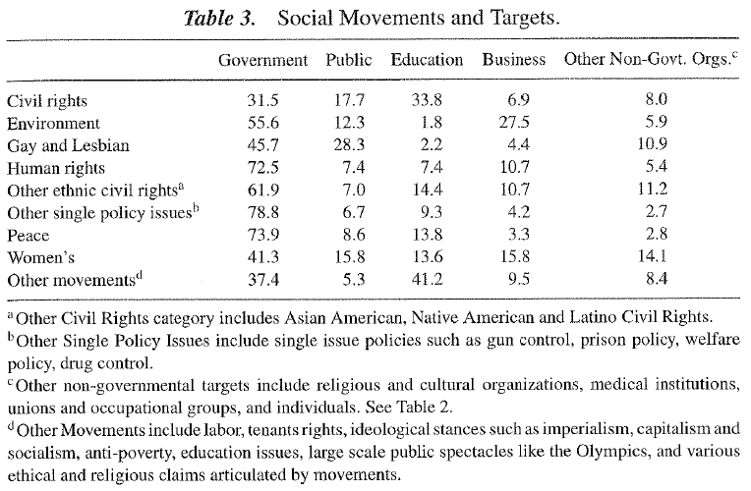
Source: Social Movements and Targets, Interest Groups and Social Groups II. Apr 2014. Powerpoint. Table 3.

