Comparative HW 3: Regime Comparison
The current understanding of democracy falls under two general schools of reason: minimalist and substantive. Minimalist democracy describes a system of government “in which the principal positions of power are filled ‘through a competitive struggle for the people’s vote’” (Diamond). As long as a country determines its leaders through a competitive electoral system, it is a democracy by the minimalist definition. Substantive democracy takes this definition further by asserting that a fair, free electoral environment is necessary to form democracy. Such a democracy must ensure basic freedoms, including “the inter alia: life, liberty and property, due process of law, equality; non-discrimination, freedom of expression and assembly, and judicial access and review,” (Inter-Parliamentary Union), are present and adhered to. A democracy, by both schools, ultimately allows for political competition, has some measure of effective public accountability of government, and is managed through free and fair elections.
Authoritarian countries are those that fail to meet the democratic definition. Political power in authoritarian regimes is centralized in a single actor or party, which take advantage of weak informal institutions to establish control over governance. Three institutional forms characterize authoritarian regimes: the dominance of a single party in the political system, military control over the civilian workings of government, and the buildup of power around a supreme executive. Authoritarian regimes do not have fair or free elections, if they have elections at all.
Of the six focus countries, only the United States, Germany and India qualify by the substantive definition as democracies. All three have democratic systems of governance by which political actors are elected through free and fair elections. Elected officials are subject to public accountability as representatives of their constituencies and thus maintain the freedoms inherent to a liberal democracy. China, Russia, and Burma do not meet the substantive definition of democracy and are thus authoritarian countries. However, both Russia and Burma undergo elections, which, while not fair or free, distinguish them from China, which has no central electoral process at all. This difference is significant enough to place them in a third group of electoral authoritarian states.
The democratic group is largely formed of liberal democracies. A liberal democracy provides enough freedoms to enable citizen participation in the political process and ensures large-scale accountability of government. All three are large, federal nations that provide for most if not all civil freedoms, such as freedom of assembly, speech, or religion. All have multiple competitive political parties, and are generally corruption free. Both Germany and the United States earned a Freedom House score of 1.0 in 2013 and are labeled liberal democracies by that institution. India received a score of 2.5, but is one of the strongest electoral democracies within the Asian region (Freedom House). All three countries have Western roots, and were thus influenced by ideals from the Enlightenment since the nineteenth century.
The three authoritarian groups all have an effective unitary structure, endemic corruption, little government transparency, largely controlled state media responses, from China’s censorship control to Burma’s recent media reform (Thornton; Freedom House). Each shows some measure of authoritarian institutions, if not more than one. China has both a single-party system and a supreme leader, Russia a personalist institution surrounding Vladimir Putin, and a military-controlled regime in Burma. Diamond classifies both China and Burma as politically closed, due to the compilation of his analysis before 2008, and Burma’s reforms (see table 1). However, the Polity IV Project as of 2011 confirms Diamond’s classification. Polity IV labels both Russia and Burma as closed anocracies, effectively similar to Diamond’s electoral autocracies, and China as a full autocracy (see fig. 1).
The electoral authoritarian group is distinct in that although the government is formed through an electoral environment, “they have the form of electoral democracy but fail to meet the substantive test,” (Diamond). Diamond argues that these hybrid regimes are intentionally pseudo-democratic. “All such regimes lack an arena of contestation sufficiently open, free and fair so that the ruling party can readily be turned out of power if it is no longer preferred by the plurality of the electorate,” (Diamond). What makes hegemonic authoritarian regimes such as Russia and Burma especially unique is their origin. The shift to the electoral system was a move to legitimize the authoritarian government as the ruler.
The central divide between the democratic group and the two authoritarian groups is the substantive difference between the electoral environments. Liberal democracies provide basic freedoms to allow for fair political competition, while authoritarian nations do not (Diamond). The democracies have competitive political parties, whereas both Burma and Russia have dominating political parties, the Union Solidarity and Development Party and the United Russia party respectively, and China is intolerant of any party but the Chinese Communist Party (CCP) (Dickson). Democracies have separation of state powers, such as the judiciary. Each of the three democratic nations has an independent judiciary; each of the authoritarian regimes does not (Freedom House). The differences between the groups exist because of the varying strength of governmental institutions among them.

Table 1
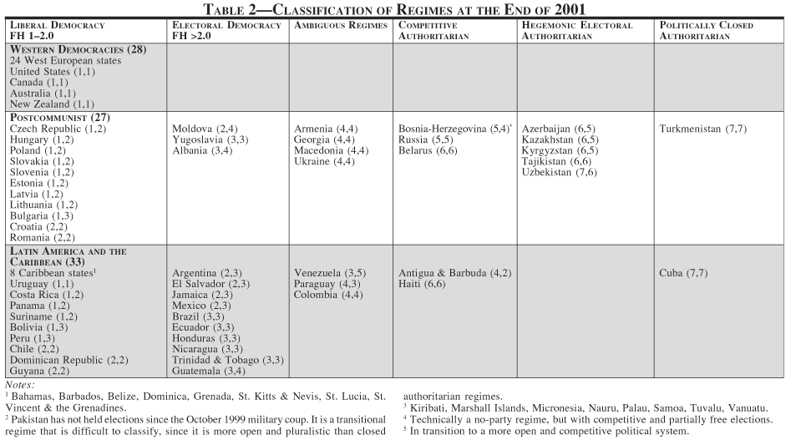
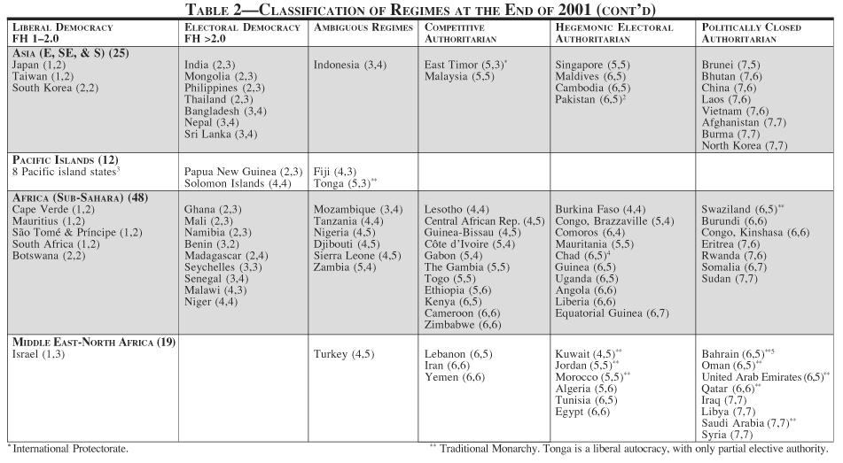
Source: National Endowment for Democracy and the Johns Hopkins University Press, Thinking About Hybrid Regimes, National Endowment for Democracy and the Johns Hopkins University Press, Mar 2014, Web.

Fig. 1
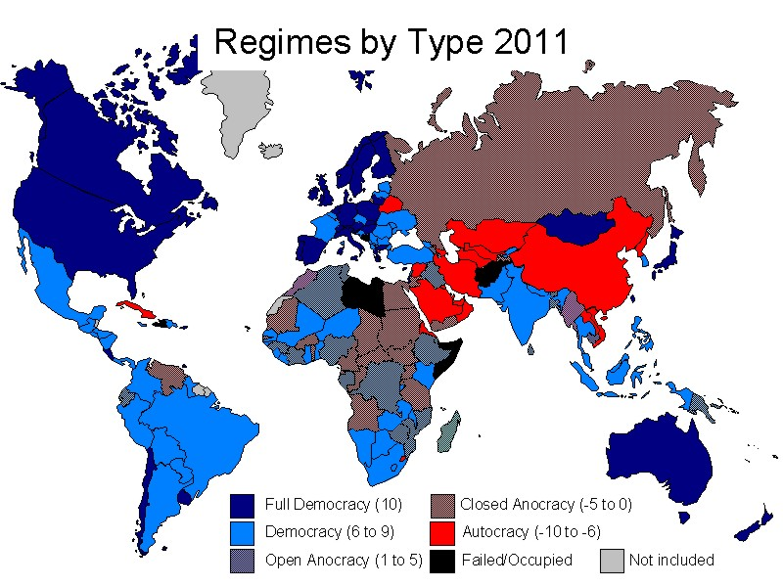

Source: Polity IV Project: Political Regime Characteristics and Transitions, 1800-2012, Polity IV Individual Country Regime Trends, 1946-2010, Polity IV Project: Political Regime Characteristics and Transitions, Mar 2014, Web.

