PUBLICITY DEPARTMENT OF THE PEOPLE’S REPUBLIC OF CHINA: MEDIA DIRECTIVE – URGENT

State Council Information Office:

Do not report on the story “Li Cunxin defects to the United States”

It is forbidden to report on the events at the Consulate General of the People’s Republic in Houston in America: the matter of Li Cunxin’s actions – his defection, the removal of his PRC citizenship, and his marriage to an American. All media is to properly assess sources for American news for capitalist or any anti-communist sentiment specifically for mentions of these events until further notice.

-/-/1981

Head of Publicity Department of the People’s Republic of China

Wang Renzhong

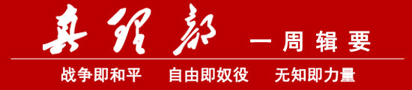

WAR IS PEACE – FREEDOM IS SLAVERY – IGNORANCE IS STRENGTH

